**e-Project Document**

**Eco Shop**

|  |  |
| --- | --- |
| **Group 3** | |
|  |  |
| **Instructor** | Mr. Nguyen Van Dinh |
| **Group Members** | Tran Anh Hung (Leader)  Nguyen Tran Tra Linh |
| **Batch** | 127 |
| **Semester** | 1 |

**TEACHER’S EVALUATION**

**MENU**

**I. ACKNOWLEDGEMENTS 4**

**II. INTRODUCTION 4**

**III. PROBLEM DEFINITION 6**

*1. Homepage 6*

*2. Product Details Page 6*

*3. Shopping Cart 7*

*4. Check out 7*

*5. Promotion Page 7*

*6. News Page 7*

*7. About us Page 7*

*8. Contact us Page 8*

*9. Search form 8*

*10. Facebook comment 8*

**IV. CRS & SITE MAP 9**

*1. Customer Requirement Specification (CRS) 9*

*2. Usecase diagram 9*

*3. Site map 12*

**V. PROJECT PLANNING 14**

**VI. GUI PROTOTYPE 15**

**VII. TECHNICAL 16**

**VIII. REFERENCES 19**

**IX. GUI OF WEBSITE 20**

**X. CHECK LIST 29**

*1. Check List of Validation 29*

*2. Submission Checklist 29*

# I. ACKNOWLEDGEMENTS

We would like to sincerely acknowledge the kindness of all the people who have given moral support and helped us make a successful project.

We wish to express our deep gratitude to the e-Project Team at the Head office, who guided and helped us. Particular thanks to **Mr.Nguyen Van Dinh** who suggested the “form validation” and help us connect storage to our project, develop the analysis proceeding from it and debugged code. We also would like to express our great gratitude to all the student members of our center (Softech Aptech).

Although we have made many attempts, because of the limited time, the practice could not be able to avoid the mistakes and missions. We hope that the our project will be considered and evaluated. And finally, we would like to offer many thanks to all our friends for their valuable suggestions and constructive feedbacks.

# II. INTRODUCTION

Today, the food safety is one of the hot social topics updated every time and from everywhere. There are many cases to show the injury of the health from toxic foods and researches has been demonstrated the relationship cause-effect between toxic foods and cancer disease. That’s reason why the needs for organic foods has been rising for 2 recent years and is now more popular in Vietnam.

To meet the needs of organic food, organic farms were built and organic stores were opened. Eco Shop is one of the first business models in Danang city, Vietnam that can be replicated at the local level to help maximize the added value of products grown and processed as organic and local farming method. Besides, Eco Shop also provides organic products imported from other countries.

The Ecoshop’s organic farm was established on July 20, 2014 on the basis of the organic farm located on La Huong farm (Cam Le District, Danang City). In March 2015, it officially open the first new store at 999 Le Van Hien Street, Ngu Hanh Son District, Danang City and was named as Eco Shop. The products are divided into 6 main categories including Vegetables, Fruits, Cereals, Beans, Nuts & Seeds, and finally, Spices.

However, the traditional shopping way is not convient for busy customers or online shoppes. Moreover, there is a huge potential needs organic food from other provinces. Therefore, It is necessary to build a online website for customers to search our products and information as well as conduct online transactions.

We created Eco shop’s website for purchasing organic products in order to create conveniently, friendly, faster and more economical for Eco shop’s users. The selected products are displayed in a tabular format and the users can order their products online through different methods of payment. By using this website, the user can now purchase products online instead of going to market or supermarket or any store. In addition to, it is convenient fo customers from other provinces can choose and buy organic products through this onine shop. They only need to access, login, search find essential information about products and conduct online transactions. Afterthat, Eco Shop sends online order confirmations to customer’s email. If there is no change or cancellation, selected organic products are packaged and shipped to customer’s address by our shipping service.

# III. PROBLEM DEFINITION

1. **Homepage**

This is the page where the user will be navigated after a successful access in website. This page is display promotion products, best seller selected by customers and upcoming products.

On each product, customer can see a quick-view product detail when they move their mouse over into a product. He/she also compares two or more products or add favourite products to his/her wishlist.

This page have a search keyword option to search for the required product. The function of shopping cart is available that customers can check information of personal detail and online orders at any time. The customer comments about shop service quality and products are included.

Finally, information of Eco shop’s address, customer service and policies are display at footer. Eco shop’s customer can also subscribe to newsletters by registering email or follow us on social networks.

1. **Product Catalogue Page**

Eco shop’s products are divided into 6 main categories including Vegetables, Fruit, Cereal, Beans, Nuts & Seeds and finally, Spices.

The product detail includes image, price and information. Customer can see a quick-view product detail when they move their mouse over into a product. Customers can easily know promotion products, bestseller list and also upcoming products.

More products are displayed when customer use the function of sort and click on next page buttons.

1. **Product detail page**

When customer move their mouse over to a product, they can see a quick-view product detail, if they like that product, they can click button “Add to cart” to add product into Shopping cart, or if they want know more information about product, they can click into product, website will go to product detail page.

In this page, the detail information includes image, price, promotion, description and also customer comments. Besides, the similar products or product in top sell are displayed.

1. **Login/Register information**

When customers login, they have to fill out information on the form including: email and Password. They can also login with Facebook or Google+ account.

If it is the first time for customers to access or visit website, they have to register before login. The register information includes full name, email, password and re-password, birthday, genderm address and phone number.

1. **Shopping cart**

Cart is an almost indispensable part of a page electronic trading of goods. Since users when they find a certain item that do not have the intention yet to buy, then they can put in the cart. Where to store the items that the customer has chosen for when they are ready to purchase. It is obviously that Shopping Cart is required.

Shopping cart is displayed the following information: product image, description, status,price, quantity, and final total. They also put any products out of orders by using the delete function.

If customers want to buy more product, they click on button continue shopping. If they want to make online orders, they move to Check out page.

1. **Checkout information**

When customer finished shopping, they have to fill out information on the form payments, including: name, email, address, payment method and voucher code.

This page also shows shopping cart information to let customer check information before they make confirmaton.

1. **News page**

The latest news are displayed in this pages. It is divided into main categories including Health, Food Tech & Science, Agricultural, Business, Life and Entertainment. It also have Eco Shop’s video and photo gallery.

The lattest news are showed in abbreviating form. If customers want to read full of articles, they click on button “read more”.

1. **News detail page**

Eco shop’s customers can read full information of articles which are showed in News page.

1. **Policy & FAQ page**

This page introduce and display about policies including Private policy, Payment policy, Shipping policy, Return & Change policy, Voucher Policy, Terms & Conditions.

Some popular customer questions can be found in this page and also accurate and full answers are given by Eco Shop.

1. **About Us Page**

This page introduces our history, our mission, our vission, our core value and our business philosophy.

1. **Contac Us Page**

This page includes Eco shop address and its location on google map. Customers can send their message to Eco shop through Contact form.

1. **Social Network**

The development of technology era today, social network is a biggest social networks. Our website has functions connected with Facebook, YouTube, Twitter, v…v… to help customers connect information and comment easily and faster.

# IV. CRS & SITE MAP

## Customer Requirement Specification (CRS)

* **Client:** Eco Shop
* **Business/Project Objective**:

The traditional shopping way is not convient for busy customers or online shoppes. Moreover, there is a huge potential needs organic food from other provinces. Therefore, it is necessary to build a online website for customers to search our products and information as well as conduct online transactions.

We created Eco shop’s website for purchasing organic products in order to create conveniently, friendly, faster and more economical for Eco shop’s users. Customers can now purchase products online instead of going to market or supermarket or any store. In addition to, it is convenient fo customers from other provinces can choose and buy organic products through this onine shop.

* Inputs provied by the client:
* Inputs to the existing system
* Outputs from the existing system
* Process involved in the application
* Expected delivery dates
* List of deliverables
* ware Requirements:
* Intel Pentium 4 processor or higher
* 1 GB RAM or higher
* Color SVGA
* 80 GB Hard Disk space
* CD-ROM or DVD-ROM drive
* Software Requirements:
* Windows 7 OS or higher
* HTML5 and JavaScript supporting browser
* HTML5 supporting mobile devices

## Use case diagram

**View homepage**

**Search product**

**View product**

**detail**

**Add to cart**



**Send comment**

**Make order**

***User***

**Connect FB,**

**YouTube, Twitter**

***User use case diagram***

1. **Site map**

# V. PROJECT PLANNING

|  |  |  |  |  |  |
| --- | --- | --- | --- | --- | --- |
| **No** | **Task Name** | **Start Date** | **End Date** | **Member** | **Status** |
| 1 | Translate Project Content | 6/16/2016 | 6/18/2016 | Tran Anh Hung, Ng.Tran Tra Linh | Completed |
| 2 | Problem Definition | 6/19/2016 | 6/20/2016 | Tran Anh Hung, Ng.Tran Tra Linh | Completed |
| 3 | Analyze Requirement Specification | 6/20/2016 | 6/21/2016 | Tran Anh Hung, Ng.Tran Tra Linh | Completed |
| 4 | Design SiteMap | 6/21/2016 | 6/22/2016 | Ng.Tran Tra Linh | Completed |
| 5 | Design Mockup Page Home | 6/23/2016 | 6/24/2016 | Ng.Tran Tra Linh | Completed |
| 6 | Design Mockup Page Product | 6/25/2016 | 6/26/2016 | Ng.Tran Tra Linh | Completed |
| 7 | Design Mockup Product Detail | 6/27/2016 | 6/28/2016 | Ng.Tran Tra Linh | Completed |
| 8 | Design Mockup Page Contact | 6/29/2016 | 6/30/2016 | Ng.Tran Tra Linh | Completed |
| 9 | Design Mockup Page AboutUS | 6/1/2016 | 6/1/2016 | Ng.Tran Tra Linh | Completed |
| 10 | Collect Information | 6/2/2016 | 6/2/2016 | Tran Anh Hung, Ng.Tran Tra Linh | Completed |
| 11 | Design Layout Home Page | 7/3/2016 | 7/8/2016 | Tran Anh Hung, | Completed |
| 12 | Design Layout Product Category Pages | 7/9/2016 | 7/10/2016 | Tran Anh Hung, | Completed |
| 13 | Design Layout Product Detail Pages | 7/10/2016 | 7/13/2016 | Tran Anh Hung, Ng.Tran Tra Linh | Completed |
| 14 | Design Layout Shoping Cart Page | 7/13/2016 | 7/13/2016 | Tran Anh Hung, | Completed |
| 15 | Design Layout Checkout Page | 7/13/2016 | 7/13/2016 | Tran Anh Hung, | Completed |
| 16 | Design Layout Policy Page | 7/14/2016 | 7/14/2016 | Ng.Tran Tra Linh | Completed |
| 17 | Design Layout News Page | 7/14/2016 | 7/14/2016 | Tran Anh Hung, | Completed |
| 18 | Design Layout New Detail Pages | 7/15/2016 | 7/18/2016 | Tran Anh Hung, Ng.Tran Tra Linh | Completed |
| 19 | Design Layout Contact Page | 6/18/2016 | 7/18/2016 | Tran Anh Hung, | Completed |
| 20 | Design Layout AboutUs Page | 7/19/2016 | 7/22/2016 | Ng.Tran Tra Linh | Completed |
| 21 | Code Shopping Cart by Jquery | 6/19/2016 | 6/19/2016 | Tran Anh Hung, | Completed |
| 22 | Design Responsive for 5 device | 7/20/2016 | 7/23/2016 | Tran Anh Hung, | Completed |
| 23 | Test Layout Responsive | 7/23/2016 | 7/23/2016 | Tran Anh Hung, Ng.Tran Tra Linh | Completed |
| 24 | Test HyperLink | 7/24/2016 | 7/26/2016 | Ng.Tran Tra Linh | Completed |
| 25 | Test Images | 7/26/2016 | 7/26/2016 | Ng.Tran Tra Linh | Completed |
| 26 | Test Code HTML5 & CSS 3 | 7/27/2016 | 7/27/2016 | Ng.Tran Tra Linh | Completed |
| 27 | Test Page Content | 7/27/2016 | 7/27/2016 | Ng.Tran Tra Linh | Completed |
| 28 | Register Hosting & release Website | 8/4/2016 | 8/4/2016 | Tran Anh Hung, | Completed |
| 29 | Translate Into English | 7/20/2016 | 7/24/2016 | Tran Anh Hung, Ng.Tran Tra Linh | Completed |
| 30 | Write Document | 7/27/2016 | 8/4/2016 | Tran Anh Hung, Ng.Tran Tra Linh | Completed |

# VI. GUI PROTOTYPE

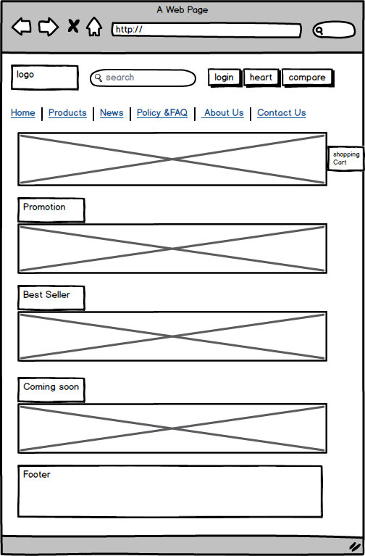

**Home Page**

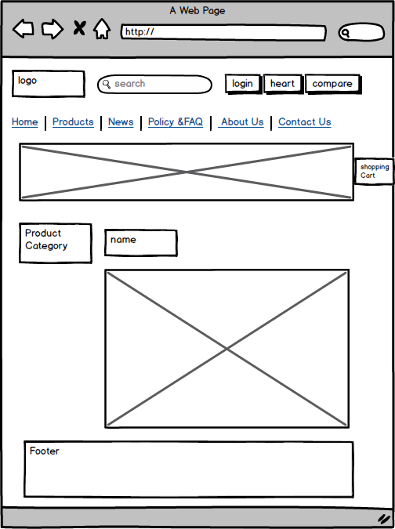

**Product Category page**

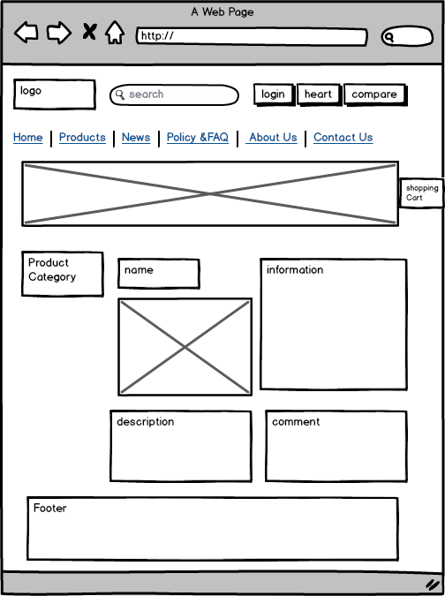

**Product detail pag**

|  |  |
| --- | --- |
|  |  |
| **News page** | **News detail page** |
|  |  |
| **Poliy & FAQ page** | **Contact Us page** |

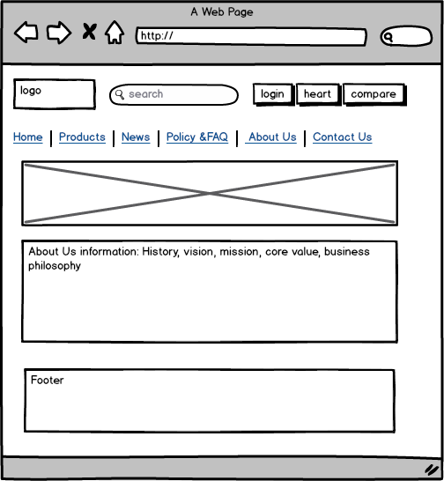

**About Us page**

**VII. TECHNICAL**

Software: WebStorm, Photoshop, Mockup

Web Browser: Blisk, Chrome, Firefox support design Responsive

The technique used to build the Website:

* HTML5 & CSS3.
* Responsive Bootstrap
* Validation for bootstrap.
* JQuery & JavaScript.
* Local Storage and Session Storage.
* Bootstrap form helpers.
* Horizontal fixed navigation.
* Fancybox JQuery
* Material for bootstrap:
* JS popover.
* JS Scrollspy.
* Modal.
* Tabs.
* BootStrap Carousel.
* Button.
* Table.
* Form.
* …….
* …….

# VIII. REFERENCES

We consulted information on the websites:

* [**http://stackoverflow.com/**](http://stackoverflow.com/)
* [**http://tutorialspoint.com**](http://tutorialspoint.com)
* [**https://jquery.com/**](https://jquery.com/)
* [**http://www.w3schools.com/**](http://www.w3schools.com/)
* **http://www.bootsnipp.com**

# IX. GUI OF WEBSITE

# 

# Home page

**Product categories pages**

# 

**Product detail pages**

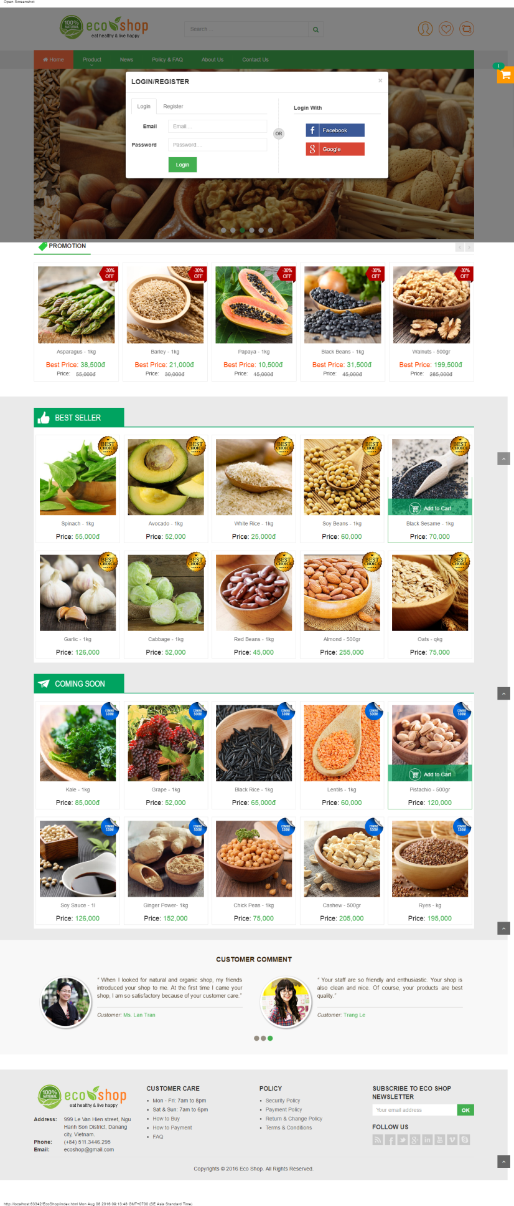

**Login**

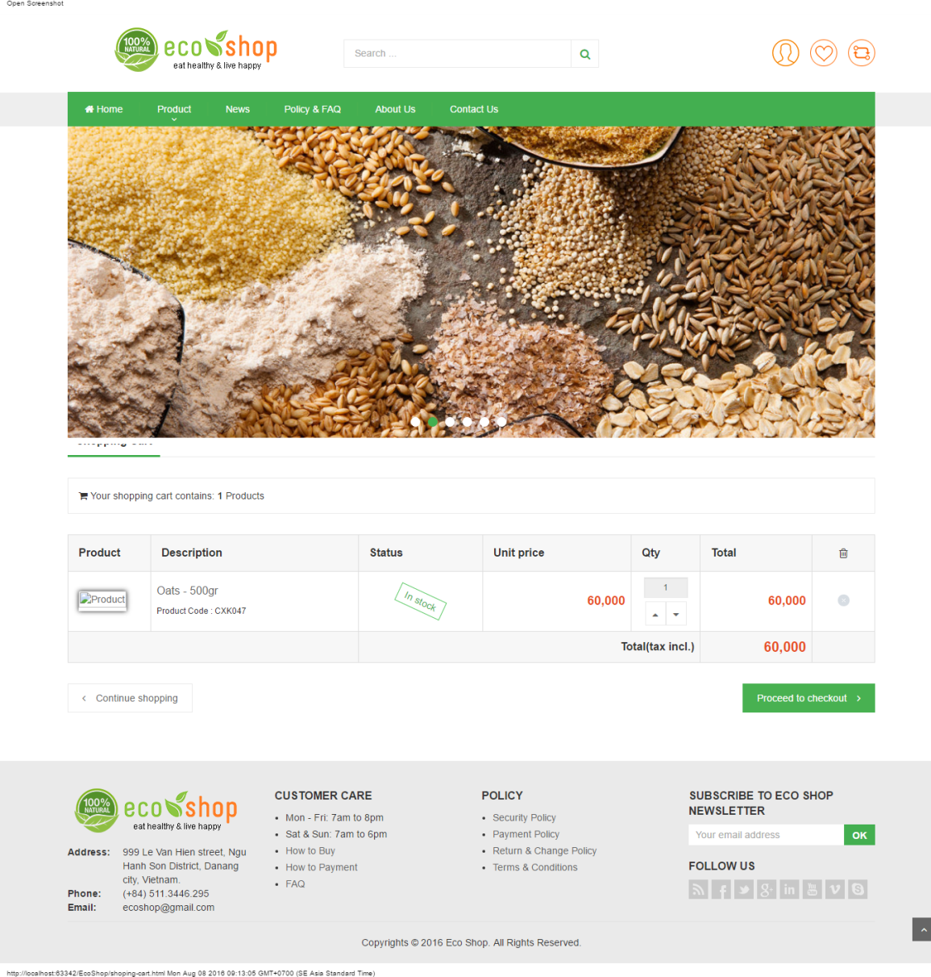

**Shopping cart**

# 

# Check out pages

**News page**

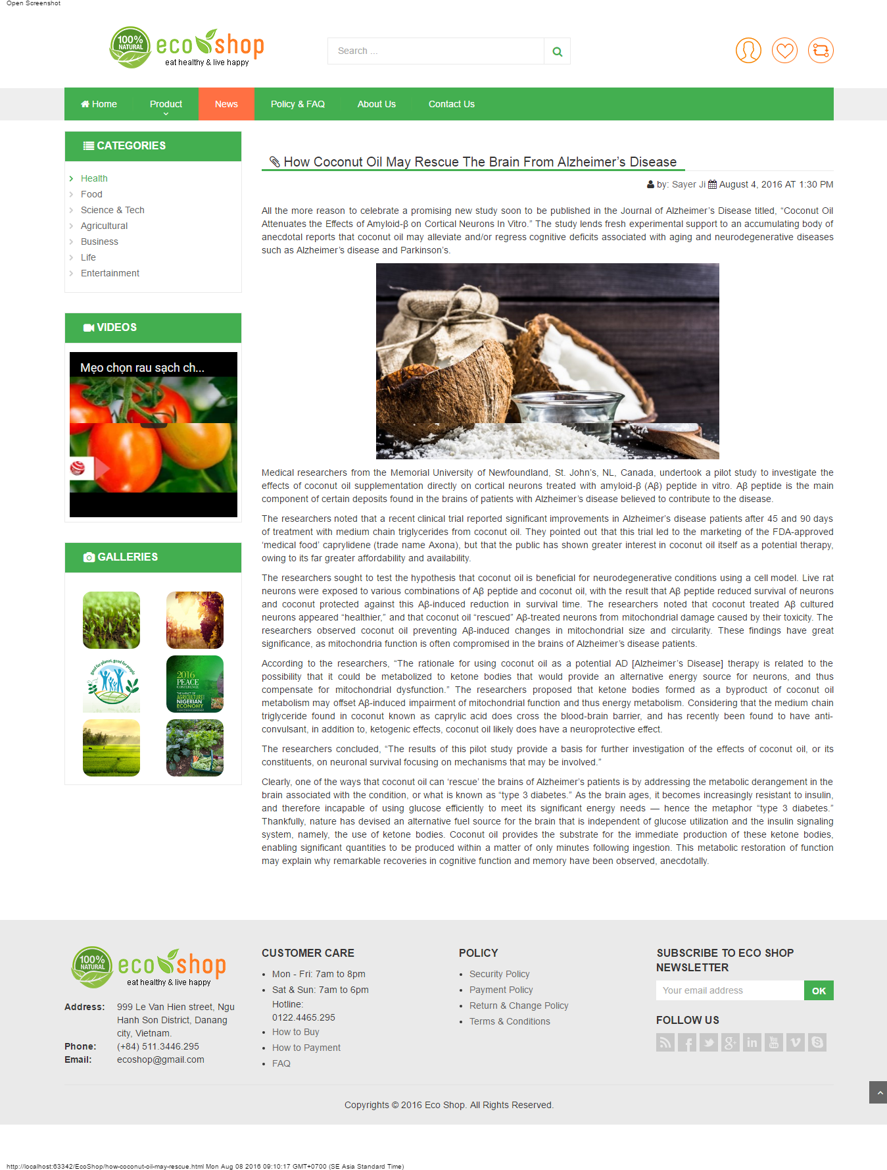

**News detail pages**

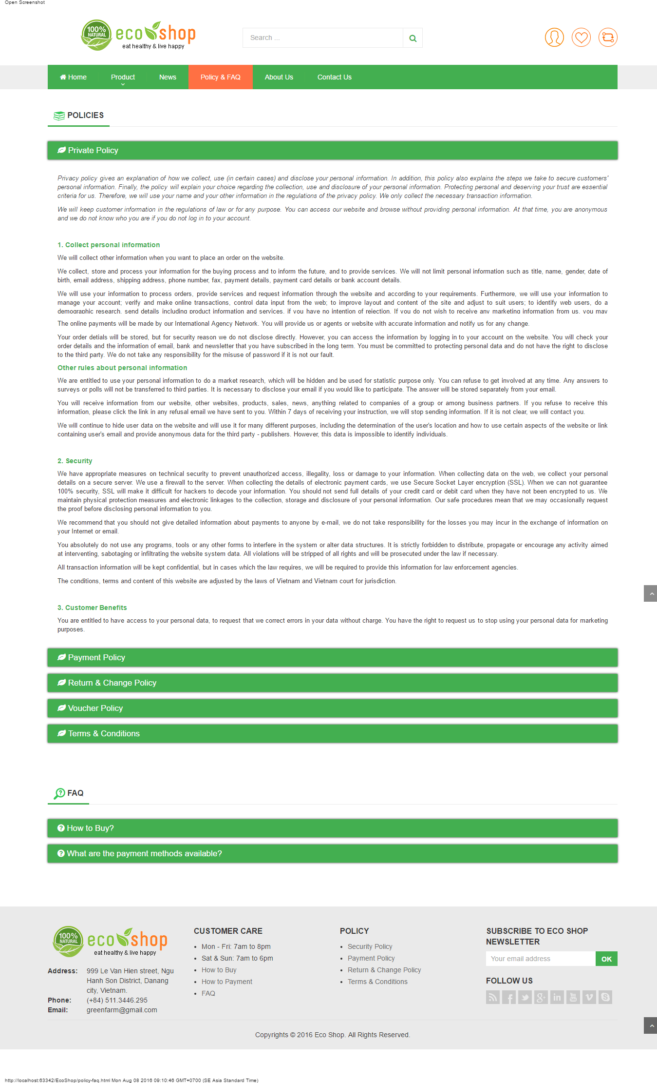

**Policy &FAQ Page**

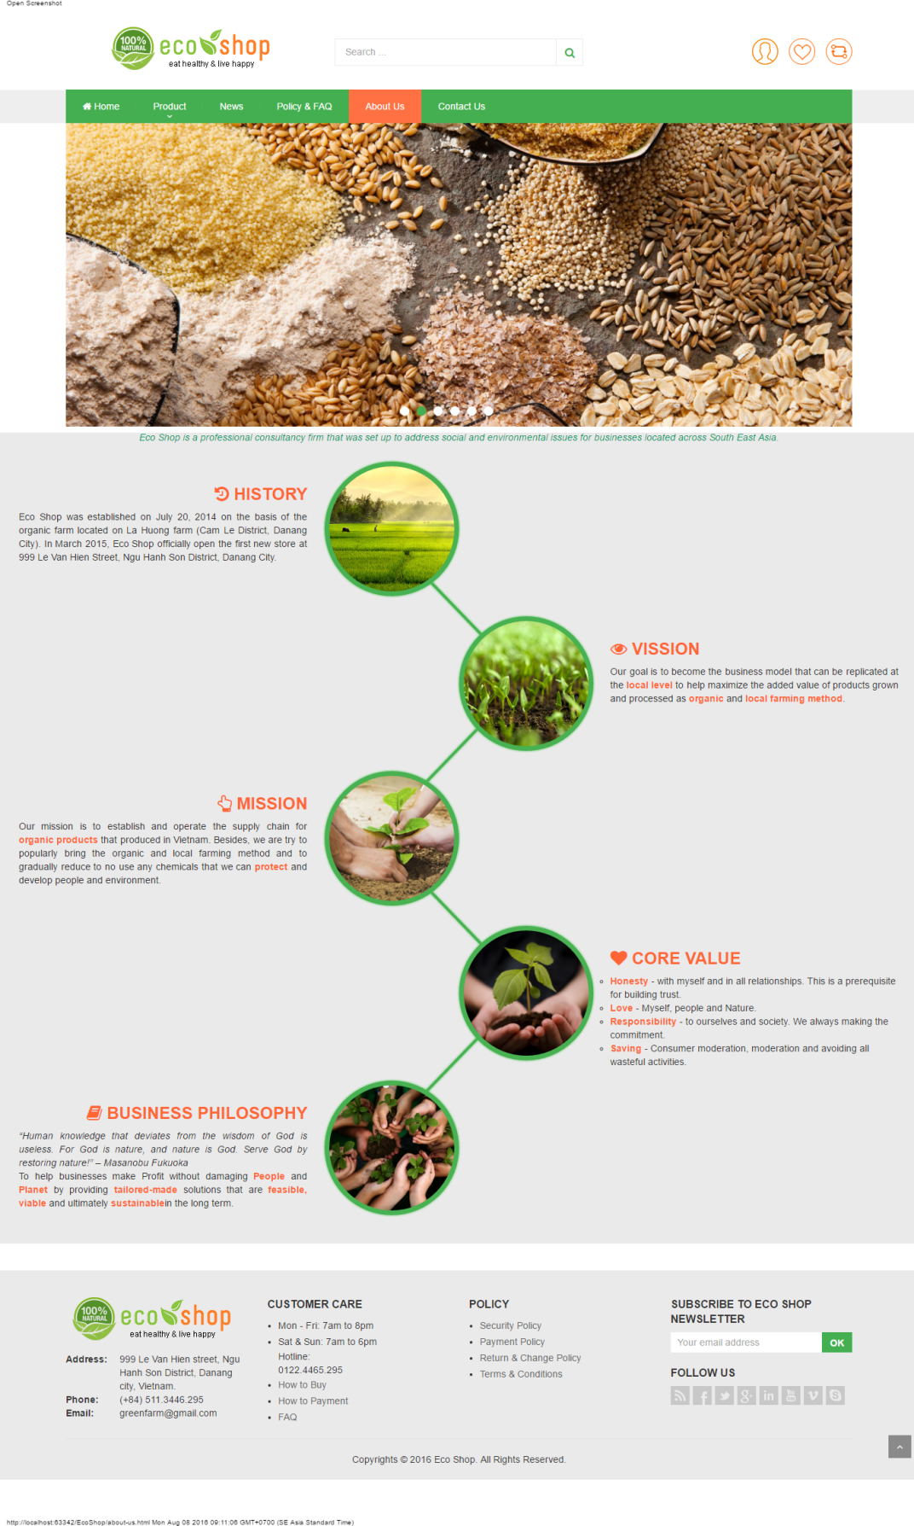

**About Us Page**

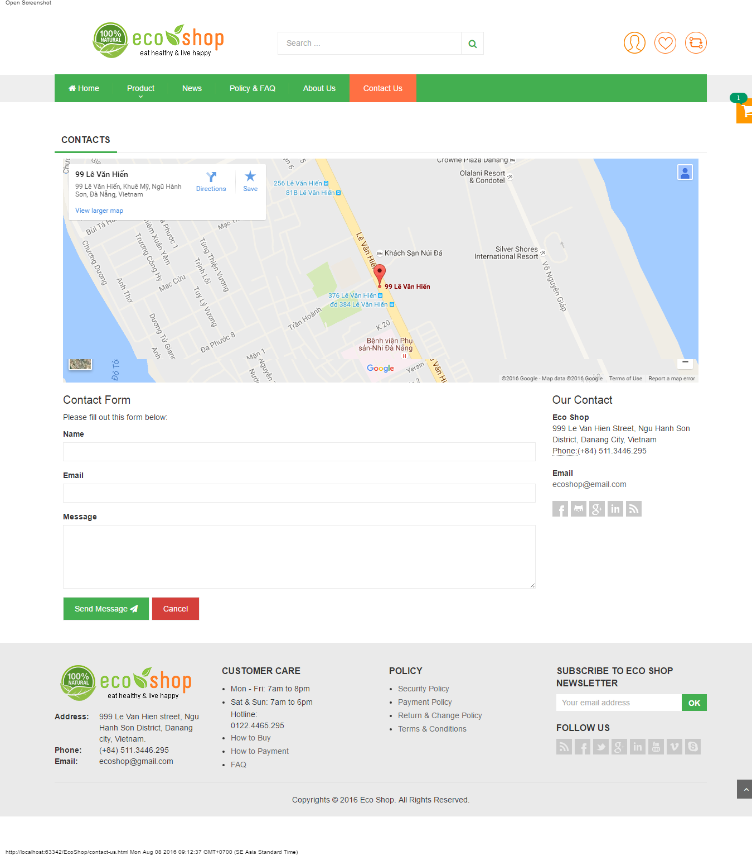

**Contact Us Page**

# X. CHECK LIST

## 1. Check List of Validation

|  |  |
| --- | --- |
| **Option** | **validate** |
| Has the hardware and software been correctly chosen? | Yes |
| Are there functions for the user to enter their comment | Yes |
| Do all the options present in the application display the correct result? | Yes |
| Are there functions cart? | Yes |
| Are there function for the user buy product? | Yes |

## 2. Submission Checklist

|  |  |  |  |  |  |
| --- | --- | --- | --- | --- | --- |
| **No.** | **Particulars** | **Yes** | **No** | **N/A** | **Comments** |
| 1 | Is the users table to login the Application on the user name and  Password? |  |  |  |  |
| 2 | Is there a form for users to enter  Personal information when buying  Or put item into the cart |  |  |  |  |
| 3 | Can the user to edit employee’s details after getting added? |  |  |  |  |
| 4 | Is the user able to find a product’s wherever they want? |  |  |  |  |
| 5 | Is the application user-friendly? |  |  |  | Windows GUI is familiar with everyone |

**XI. CONCLUTION**

Eco Shop website includes: Home page, Product Categories pages, Product Detail pages, News page, News Detail pages, Policy page, About Us page, Contact Us page, Login/Resgister, Shopping Cart and Check Out.

However, this website also need to be develop and upgrated.

Here is the development direction:

1. Complete or perfect remaing parts of this website
2. Change background image and color, font and other as required by the client
3. Develop mobile-optimized website with functions such as: [Website Responsive](https://www.mypage.vn/thiet-ke-web-theo-chuan-mobile.html), [Responsive Design](https://www.mypage.vn/thiet-ke-web-theo-chuan-mobile.html),..
4. Build back-end (Manager/Administrator) for this website
5. Upgrate static website to dynamic website by using java, C#, php, ruby on rails,…
6. Build webApp.